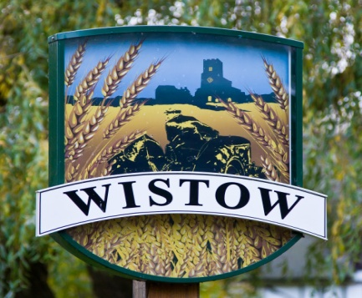

Wistow Parish Council,

Analysis of bank reconciliation variance from November 2022

The variance was £6.24 and was caused by 2 errors one of overpayment and one of not paid

The Parish Clerk was the counterparty on both occasions

He was over paid £5.00 in respect of the purchase of Avast anti-virus software; but he was not paid £11.25 owed for approved mileage.

In effect the PC was underpaid but in the circumstance it is wrong to expect the council to underwrite his mistake causing the £6.24 variance

The remaining 1 pence variation is due to rounding

M Woolhouse
Parish Clerk

15 April 2023

This includes the 5% Increase that was voted for by the Parish Council in 2018

Please make your cheque payable to Wistow Parish Council
Transfers can be made to Barclays Bank Account, Wistow Parish Council
Sort Code 20-43-63 Account number 13958094

For information, I have succeeded Mike Tew as Parish Council Clerk, so please send your remittance (or advice) to me at the address below.

Yours sincerely

Martin Woolhouse
Wistow Parish Council
7 Howards Meadow
Kings Cliffe
Nr Peterborough
Northants
PE8 6YJ

